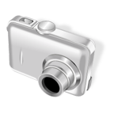I grant Little Sprouts Learning Center the right to take photographs of my child in connection with childcare experiences at the facility.
I agree that Little Sprouts Learning Center may use such photographs of my child without my name and for any lawful purpose, including such purposes as publicity, illustration, advertising, and Web content.
I have read and understand the above.

Signature ______________________________

Printed name ______________________________
Child’s name ______________________________
Date _____________________________________

